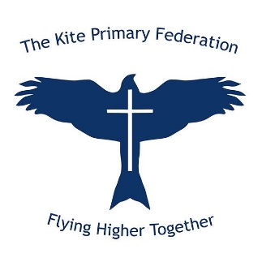
The Kite Primary Federation Governing Board Committees
COMMITTEES 2025 – 2026
Committee | Chair | Members | Terms of Ref | Quorate
Finance & HR  Incl Premises | Al Eadie | Jo Lagares (EHT)  Karen Smith (CofG)  Peter Collison (Vice CofG)  Sam Walker  Ed Miller | Minimum of 4  Must include EHT and CoG | 2 + EHT
Policies | Larry Hayes | Jo Lagares (EHT)  Pete Collison (Vice CofG)  Mike Griffiths  George Punter | 5  Must include EHT | 2 + EHT
Curriculum | Karen Smith | Jo Lagares (EHT)  Mel Kilding (DHT, Assoc.)  Mark Wilson (DHT, Assoc.)  George Punter  Kirsty Terry  Nikki Crosse  Chris Smith  Larry Hayes | 4  Must include EHT  Plus DHT, Assoc. | 2 + EHT
Admissions | Kirsty Terry | Jo Lagares (EHT)  Karen Smith (CofG)  Larry Hayes | 4  Must include EHT and CoG | 2 + EHT
EHT PM | Karen Smith (CoG) | Al Eadie  Mike Griffiths  Chris Smith | 4  Must include CoG | 3
EHT Appeals Panel | Peter Collison (Vice CofG) | Larry Hayes  Kirsty Terry | 3  Must include Vice CoG | 3
EHT Pay Committee | Karen  (CofG) | Pete Collison (Vice CofG)  Al Eadie  Mike Griffiths | 3  Must include CoG | 3

